**PRASATH D - 212221020033**

**EXP - 3**

**Evaluation of Prompting Tools Across Diverse AI Platforms: ChatGPT, Claude, Bard,**

**Cohere Command, and Meta**

**AIM:**

Within a specific use case (e.g., summarising text, answering technical questions), compare the performance, user experience, and response quality of prompting tools across these different AI platforms.

**PROMPT:**

Uploaded a research paper titled “**Recent advance in using eco-friendly carbon-based conductive ink for printed strain sensor: A review**” from malaysia in ELSEVIER journal in the year 2024.

**CHATGPT:**

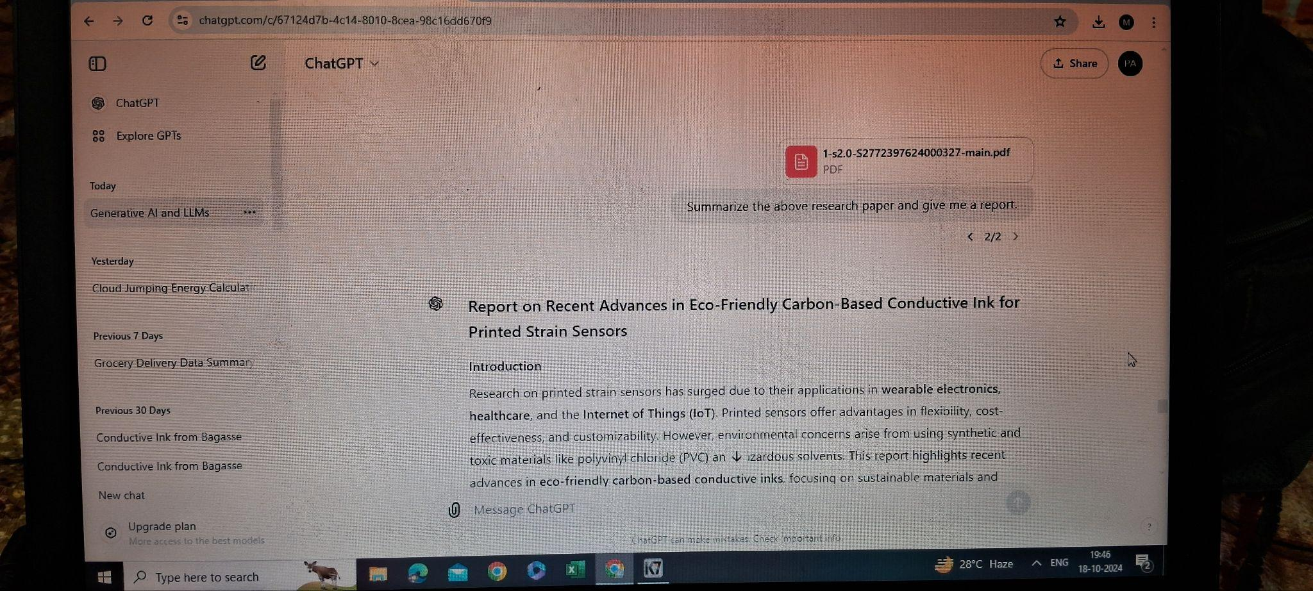

**QUILLBOT:**

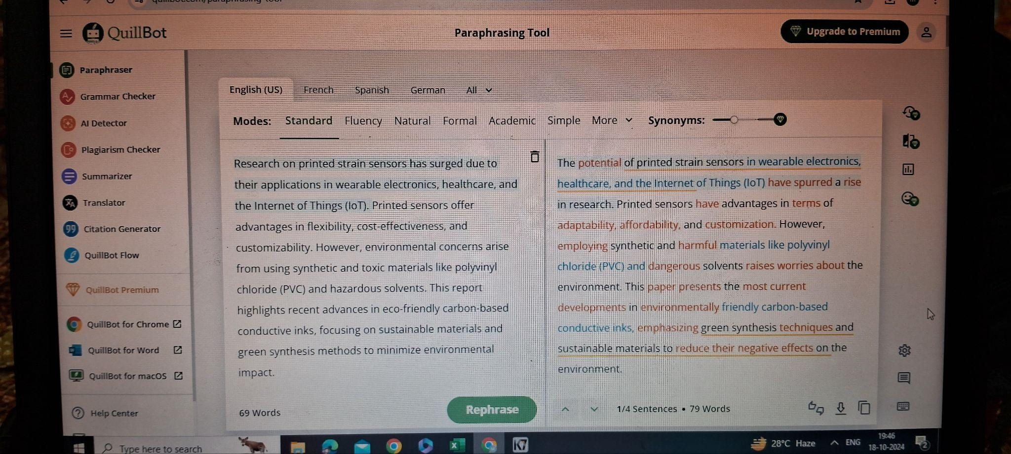

|  |  |  |
| --- | --- | --- |
| **Feature** | **ChatGPT** | **QuillBot** |
| Primary Function | Conversational AI for generating text, answering questions, and assisting with various tasks | Paraphrasing, summarizing, and rewording text for clarity and conciseness. |
| Use Cases | Dialogue generation, creative writing, research, coding help, general knowledge assistance. | Paraphrasing, improving writing clarity, grammar checking, summarizing content. |
| AI Model | GPT-based (by OpenAI), focuses on conversational abilities and context understanding. | Uses its proprietary AI models designed for paraphrasing and summarizing. |
| Content Types | Text generation, explanations, creative writing, essays, code, and more. | Paraphrasing, summarizing, sentence rephrasing, plagiarism checking. |
| Language Support | Multilingual with varying degrees of fluency across languages. | Supports paraphrasing in multiple languages, optimized for English writing. |
| Accuracy & Fluency | Highly context-aware, can maintain conversation and generate coherent long texts. | Focused on rewording and clarity improvement, best for short-to-medium length texts. |

**SUMMARY:**

* **CHATGPT:**

Generate human-like conversations and answer questions.

Help with writing, brainstorming ideas, coding, and research tasks.

Provide tutoring, explanations, and clarifications on complex subjects.

* **QUILLBOT:**

Paraphrase or rephrase text for clarity, conciseness, and tone adjustments.

Improve grammar and spelling in written content.

Assist in avoiding plagiarism by rewording content in a unique way.